Asa Hayes CSCE-121-700 Moore 16 June 2017
Design Document: Bulls & Cows
1. Pseudocode: Extract individual digits from an int.

start codeblock
set the int
create a vector
assign the int to a temporary int for the loop

for (iterate down from (number of digits) to 0)
use integer division to get the digit from the current position
place digit into vector
remove the processed digit
end loop

2. Pseudocode: Create random code and place it in a list

get seed for random number generator
using seed, generate an int with (user-input (3, 4, or 5)) digits

use the above code, possibly as a method, to separate this int into its digits as well

3. Flowchart for determining number of bulls and cows (next page)
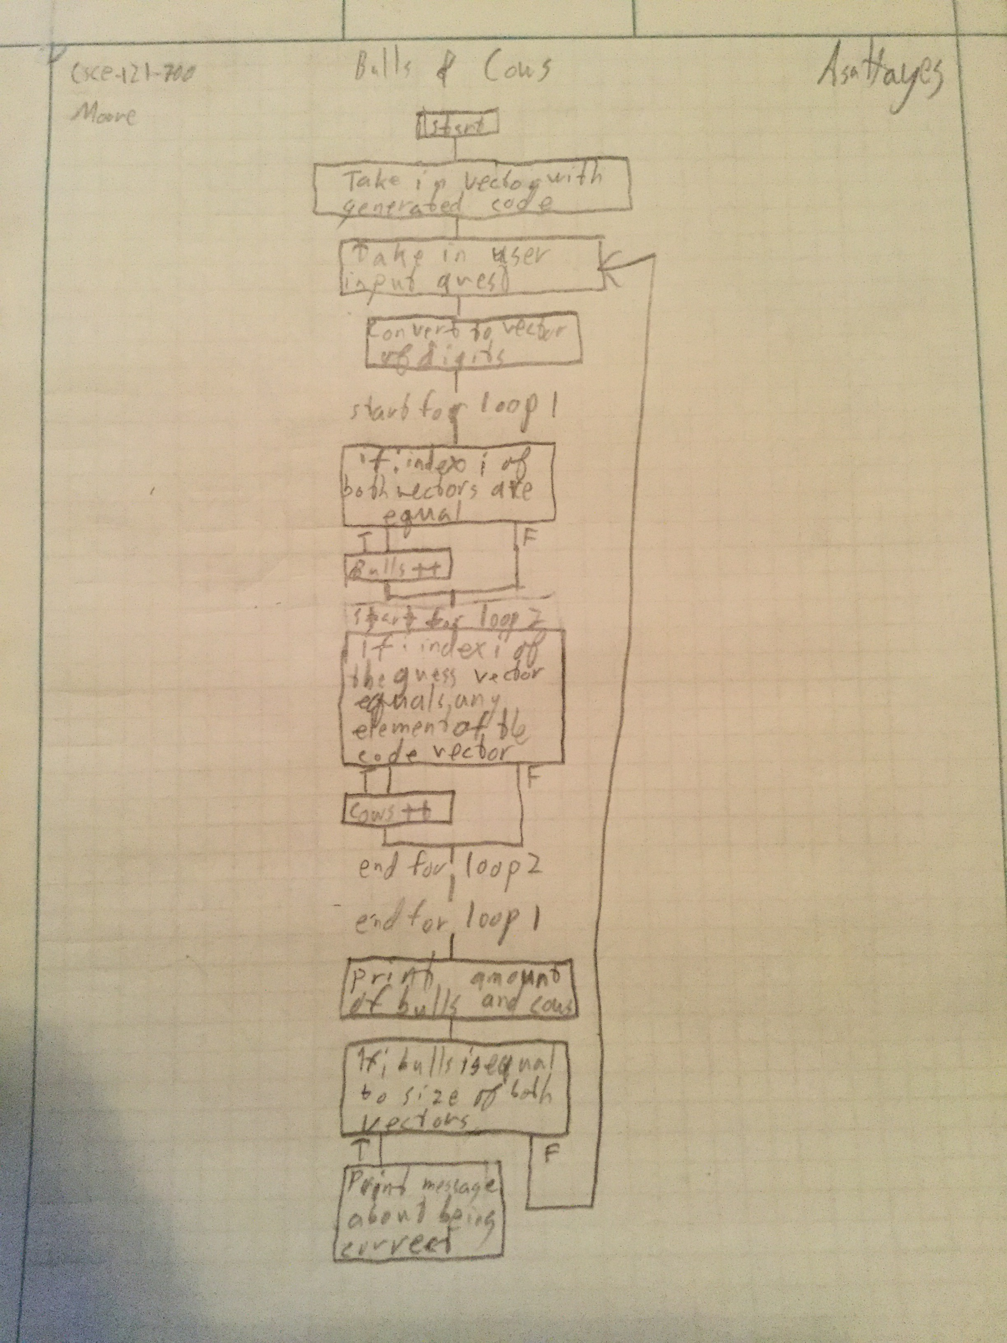
4. Test Cases:
- Inputs of 0
  - Enter 3 digit code
  - Enter 4 digit code
  - Enter 5 digit code
  - Invalid code by format or size
- Inputs of 3
- Inputs of 4
- Inputs of 5
- Invalid inputs
- Input guesses
  - valid, invalid, and wrong types
- Find if loop to beginning functions if user prefers

